1ПИб-02-1оп-22 Микуцких Григорий

|  |  |  |
| --- | --- | --- |
| 13 | Описание и работа со *структурами и объединениями* языка С++. | Микуцких Г. |

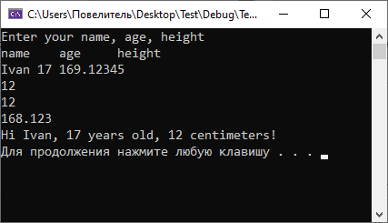

#include <iostream>

#define _USE_MATH_DEFINES

#include <math.h>

using namespace std;

/*

multi-line comment

*/

struct Person {//creating a structure

union Height {//creating a union

int int_height;

size_t size_t_height;

double double_height;

} height = { -1 };

string name = "noname";

int age = -1;

};

//

int main() {

Person man;

cout << "Enter your name, age, height\nname\tage\theight" << endl;

cin >> man.name >> man.age >> man.height.double_height;

if (man.age >= 18)

man.age &= man.age xor man.height.int_height;

else if (man.height.double_height > 150)

man.height.int_height = sqrt(--man.height.double_height);

else

(man.age > 100)/*comment inside the formula*/? man.age %= 2 : man.age |= man.age;

cout << "Hi " + man.name + ", " << man.age << " years old, " << man.height.int_height << " centimeters!" << endl;

system("pause");

return 0;

}